Unit 6 Do you like bananas
第1课时
教师寄语：All the bright precious things fade so fast and they don't come back.
美好的事物总是转瞬即逝，一去不返
【预习导学】
1、学习目标
- 学习一些关于食物和饮料的单词，并能谈论自己和他人对食物的喜恶。
- 初步了解可数名词、不可数名词的概念。
- 要建立良好的饮食习惯，树立健康饮食的观念。
- 自学任务
Task 1 文化连接—Lunch from home.
In the US, many people bring lunch from home. Students may carry their lunches in a lunch box or paper bag. Having a healthy lunch is considered(认为) to be very important.
Task2 根据音标自学本课时的新单词，特别注意单词的词性和词义，读一读。
单词 | 词性 | 词义 | 单词/词组 | 词性 | 词义
banana |  |  | sure
hamburger |  |  | vegetable
tomato |  |  | fruit
ice cream |  |  | right
strawberry |  |  | apple
salad |  |  | then
pear |  |  | egg
milk |  |  | carrot | /
bread |  |  | rice
birthday |  |  | chicken
dinner |  |  | so
week |  |  | think about | /
food |  |  | How about

Task3 头脑风暴——观察课本P31 1a 中的图片，尽可能写出有关食物和饮料的单词。
Food:_________________________________________________________________________________________________________________________________________________________Drink:______________________________________________________________ _______________________________________________________________________________
Task4 找找图片里有什么是你和你身边人喜欢的食物和饮料,并仔细观察例句，试着造句来表达他们对食物的喜恶吧！别忘了自己读读单词和句子哦。
Food and Drink | Somebody | Like | Dislike（不喜欢）
hamburgers/chips | I | I like hamburgers. | But I don’t like chips..
oranges/apples | my mother | She likes oranges. | But she doesn’t like apples.

Task 5 观察上列表格，为什么表示食物的单词有的是复数，而有的是单数呢？
- Read the rules about nouns. （可数名词和不可数名词的规则）
We can count(数) countable nouns（可数名词）: one apple, two apples, three apples. | We can’t count uncountable nouns（不可数名词）: fruit, two fruits, six fruits.

- Copy and complete the table with the nouns in the box.
banana, pear, bread, hamburger, salad, ice-cream,
orange , tomato, strawberry, milk , fruit, apple.

Countable nouns | Uncountable nouns
apple | fruit

Summary（总结）：With countable nouns we can/ can’t use a, an, or numbers.
With uncountable nouns we can/ can’t use a, an, or numbers.
【课堂活动】
Step 1 Watch a video
Please watch a video about “Do you like…?”

Step 2 Picture talk
Describe the pictures in 1a

Step 3 Pair work
Practice the conversation by picture dictionary in pair.
A: I like …. , but I don’t like …Do you like …?
B: Yes, I do. I like it/them. /No, I don’t.
A.: Let’s have bananas.
B: That sounds…

Step4 Listening and speaking practice
Activity 1b
- Listen to the recording for the first time and finish 1b.
- Listen for the second time and fill in the blanks.
Conversation1
Boy: ______you like banana?
Girl: Yes, I _______ .
Conversation2
Boy: Do you like _______?
Girl: No, I______ .
Conversation3
Boy: Do you like ______?
Girl: Yes, I_______ .
Activity 2a, 2b
- Listen for the first time and finish 2a.
- Listen for the second time and finish 2b.
- Listen for the third time and fill in the blanks.
Conversation1
Girl: I like hamburgers. Do you like hamburgers?
Boy: Yes, _____do.
Conversation2
Girl: Do you like _______?
Boy: No, I don’t like tomatoes.
Conversation3
Girl: ______ have ice-cream?
Boy: Oh, no.
Girl: No?
Boy: I don’t ______ ice-cream.
- Listen for the fourth time and answer the following questions.
  - Does the boy like hamburgers? How about the girl?
_______________________________________________
  - Does the boy like tomatoes?
_______________________________________________
  - Does the boy like ice-cream?
_______________________________________________
Step 5 Role-play the conversations
- Look at the picture in 2d and ask the questions.(What do they want to eat?)
- Read the conversation in 2d together.
- Role-play the conversation.
【训练反馈】
1. Complete the descriptions.
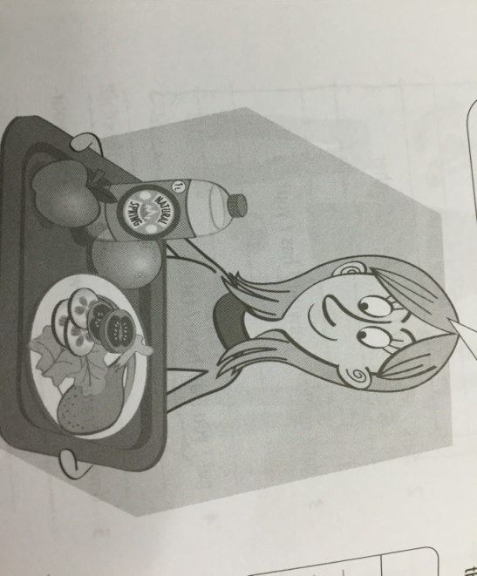
I like some chicken and .
I have an and an .
I also have a litre(公升) of .
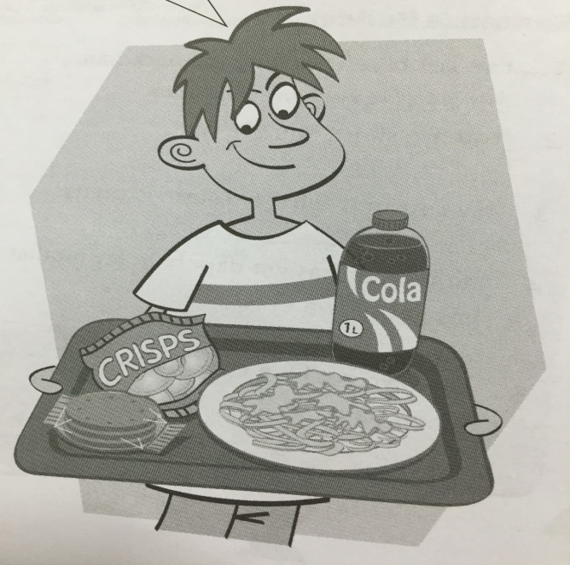

He likes some .
He likes some and .
He also has a litre of .

